**ЛАБОРАТОРНА РОБОТА № 7**

**Варіант 2**

Адаптивна верстка. Робота з трансформаціями.

***Мета*** : Навчитися створювати адаптивні веб-сторінки.

**Хід роботи:**

**Завдання 1**:



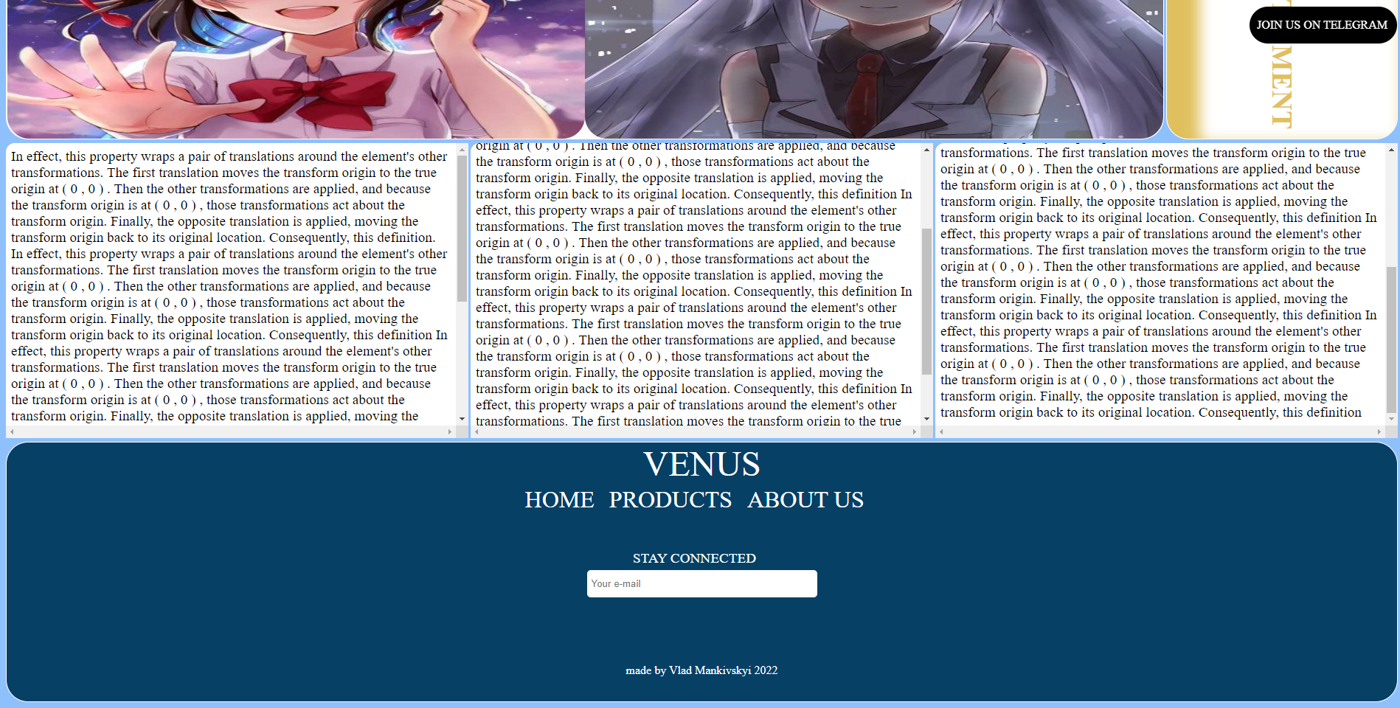

**HTML:**

<!DOCTYPE *html*>

<html *lang*="en">

  <head>

    <meta *charset*="UTF-8" />

    <meta *http-equiv*="X-UA-Compatible" *content*="IE=edge" />

    <meta *name*="viewport" *content*="width=device-width, initial-scale=1.0" />

    <link *rel*="stylesheet" *href*="task.css" />

    <title>task</title>

  </head>

  <body>

    <div *class*="grid">

      <div *class*="top"><div *class*="top_text">AWESOME</div></div>

      <div *class*="img">

        <img *src*="img/1.jpg" *alt*="" />

        <img *src*="img/2.jpg" *alt*="" />

        <img *src*="img/3.jpg" *alt*="" />

        <img *src*="img/4.jpg" *alt*="" />

      </div>

      <div *class*="center_right">

        <div *class*="center_right_text">PLACE FOR YOUR ADVERTISMENT</div>

      </div>

      <div *class*="bottom_text">

        <div *class*="bottom_text_left">

          In effect, this property wraps a pair of translations around the

          element's other transformations. The first translation moves the

          transform origin to the true origin at ( 0 , 0 ) . Then the other

          transformations are applied, and because the transform origin is at (

          0 , 0 ) , those transformations act about the transform origin.

          Finally, the opposite translation is applied, moving the transform

          origin back to its original location. Consequently, this definition.

          In effect, this property wraps a pair of translations around the

          element's other transformations. The first translation moves the

          transform origin to the true origin at ( 0 , 0 ) . Then the other

          transformations are applied, and because the transform origin is at (

          0 , 0 ) , those transformations act about the transform origin.

          Finally, the opposite translation is applied, moving the transform

          origin back to its original location. Consequently, this definition In

          effect, this property wraps a pair of translations around the

          element's other transformations. The first translation moves the

          transform origin to the true origin at ( 0 , 0 ) . Then the other

          transformations are applied, and because the transform origin is at (

          0 , 0 ) , those transformations act about the transform origin.

          Finally, the opposite translation is applied, moving the transform

          origin back to its original location. Consequently, this definition In

          effect, this property wraps a pair of translations around the

          element's other transformations. The first translation moves the

          transform origin to the true origin at ( 0 , 0 ) . Then the other

          transformations are applied, and because the transform origin is at (

          0 , 0 ) , those transformations act about the transform origin.

          Finally, the opposite translation is applied, moving the transform

          origin back to its original location. Consequently, this definition In

          effect, this property wraps a pair of translations around the

          element's other transformations. The first translation moves the

          transform origin to the true origin at ( 0 , 0 ) . Then the other

          transformations are applied, and because the transform origin is at (

          0 , 0 ) , those transformations act about the transform origin.

          Finally, the opposite translation is applied, moving the transform

          origin back to its original location. Consequently, this definition

        </div>

        <div *class*="bottom_text_center">

          In effect, this property wraps a pair of translations around the

          element's other transformations. The first translation moves the

          transform origin to the true origin at ( 0 , 0 ) . Then the other

          transformations are applied, and because the transform origin is at (

          0 , 0 ) , those transformations act about the transform origin.

          Finally, the opposite translation is applied, moving the transform

          origin back to its original location. Consequently, this definition.

          In effect, this property wraps a pair of translations around the

          element's other transformations. The first translation moves the

          transform origin to the true origin at ( 0 , 0 ) . Then the other

          transformations are applied, and because the transform origin is at (

          0 , 0 ) , those transformations act about the transform origin.

          Finally, the opposite translation is applied, moving the transform

          origin back to its original location. Consequently, this definition In

          effect, this property wraps a pair of translations around the

          element's other transformations. The first translation moves the

          transform origin to the true origin at ( 0 , 0 ) . Then the other

          transformations are applied, and because the transform origin is at (

          0 , 0 ) , those transformations act about the transform origin.

          Finally, the opposite translation is applied, moving the transform

          origin back to its original location. Consequently, this definition In

          effect, this property wraps a pair of translations around the

          element's other transformations. The first translation moves the

          transform origin to the true origin at ( 0 , 0 ) . Then the other

          transformations are applied, and because the transform origin is at (

          0 , 0 ) , those transformations act about the transform origin.

          Finally, the opposite translation is applied, moving the transform

          origin back to its original location. Consequently, this definition In

          effect, this property wraps a pair of translations around the

          element's other transformations. The first translation moves the

          transform origin to the true origin at ( 0 , 0 ) . Then the other

          transformations are applied, and because the transform origin is at (

          0 , 0 ) , those transformations act about the transform origin.

          Finally, the opposite translation is applied, moving the transform

          origin back to its original location. Consequently, this definition

        </div>

        <div *class*="bottom_text_right">

          In effect, this property wraps a pair of translations around the

          element's other transformations. The first translation moves the

          transform origin to the true origin at ( 0 , 0 ) . Then the other

          transformations are applied, and because the transform origin is at (

          0 , 0 ) , those transformations act about the transform origin.

          Finally, the opposite translation is applied, moving the transform

          origin back to its original location. Consequently, this definition.

          In effect, this property wraps a pair of translations around the

          element's other transformations. The first translation moves the

          transform origin to the true origin at ( 0 , 0 ) . Then the other

          transformations are applied, and because the transform origin is at (

          0 , 0 ) , those transformations act about the transform origin.

          Finally, the opposite translation is applied, moving the transform

          origin back to its original location. Consequently, this definition In

          effect, this property wraps a pair of translations around the

          element's other transformations. The first translation moves the

          transform origin to the true origin at ( 0 , 0 ) . Then the other

          transformations are applied, and because the transform origin is at (

          0 , 0 ) , those transformations act about the transform origin.

          Finally, the opposite translation is applied, moving the transform

          origin back to its original location. Consequently, this definition In

          effect, this property wraps a pair of translations around the

          element's other transformations. The first translation moves the

          transform origin to the true origin at ( 0 , 0 ) . Then the other

          transformations are applied, and because the transform origin is at (

          0 , 0 ) , those transformations act about the transform origin.

          Finally, the opposite translation is applied, moving the transform

          origin back to its original location. Consequently, this definition In

          effect, this property wraps a pair of translations around the

          element's other transformations. The first translation moves the

          transform origin to the true origin at ( 0 , 0 ) . Then the other

          transformations are applied, and because the transform origin is at (

          0 , 0 ) , those transformations act about the transform origin.

          Finally, the opposite translation is applied, moving the transform

          origin back to its original location. Consequently, this definition

        </div>

      </div>

      <footer>

        <form>

          <div *class*="footer_top">VENUS</div>

          <div *class*="footer_top_bottom">

            <div>HOME</div>

            <div>PRODUCTS</div>

            <div>ABOUT US</div>

          </div>

          <div *class*="email_text">

            <label *for*="email">STAY CONNECTED</label>

          </div>

          <div *class*="email">

            <input

*id*="email"

*type*="email"

*name*="email"

*required*="required"

*autocomplete*="off"

*placeholder*="Your e-mail"

            />

          </div>

          <div *class*="footer_bottom">made by Vlad Mankivskyi 2022</div>

        </form>

      </footer>

    </div>

    <div *class*="fix"><div>JOIN</div></div>

  </body>

</html>

**CSS:**

body {

  background-color: #8ec0fb;

}

*.grid* {

  display: grid;

  grid-template-columns: 2.5fr 0.5fr;

  grid-column-gap: 3px;

  grid-row-gap: 5px;

}

*.top* {

  border: 1.5px solid white;

  grid-column-start: span 2;

  position: relative;

  width: 100%;

  height: 200px;

  background-color: #064065;

  border-radius: 10px;

}

*.top_text* {

  position: absolute;

  left: 50%;

  top: 50%;

  transform: translate(-50%, -50%);

  font-size: 4em;

  color: white;

  text-shadow: -2px -2px 2px #ce5937, -2px -2px 2px #ce5937;

}

*.top_text::before* {

  content: "the_";

}

*.top_text::after* {

  content: "_site";

}

*.img* {

  display: grid;

  grid-template-columns: 1.5fr 1.5fr;

  grid-template-rows: repeat(2, 372px);

  background-color: white;

  border-radius: 30px;

  border: 1.5px solid white;

}

img {

  transition: all 0.2s;

  width: 100%;

  height: 100%;

  border-radius: 30px;

}

img*:hover* {

  transform: scale(1, 1.71875);

}

img*:nth-child*(1)*:hover* {

  transform-origin: top left;

}

img*:nth-child*(2)*:hover* {

  transform-origin: top right;

}

img*:nth-child*(3)*:hover* {

  transform-origin: bottom left;

}

img*:nth-child*(4)*:hover* {

  transform-origin: bottom right;

}

*.center_right* {

  border: 1.5px solid white;

  position: relative;

  background-color: white;

  border-radius: 30px;

  writing-mode: tb-rl;

*-webkit-box-shadow*: inset 25px 25px 18px 19px #e0c05d;

  box-shadow: inset 25px 25px 18px 19px #e0c05d;

}

*.center_right_text* {

  font-size: 2.4em;

  color: #e0c05d;

  position: absolute;

  top: 70px;

  left: 43%;

  font-weight: bold;

}

*.bottom_text* {

  grid-column-start: span 2;

  display: grid;

  grid-template-columns: 1.5fr 1.5fr 1.5fr;

  grid-column-gap: 3px;

  grid-template-rows: repeat(1, 400px);

}

*.bottom_text* div {

  padding: 7px;

  background-color: white;

  border-radius: 12px;

  font-size: 1.2em;

  overflow: scroll;

}

*.bottom* {

  background-color: blue;

  grid-column-start: span 2;

}

footer {

  border: 1.5px solid white;

  grid-column-start: span 2;

  background-color: #064065;

  height: 350px;

  border-radius: 30px;

}

*.footer_top* {

  padding-top: 3 px;

  text-align: center;

  font-size: 3em;

  color: white;

}

*.footer_top_bottom* {

  position: absolute;

  left: 50%;

  padding-top: 3px;

  transform: translate(-50%, 0);

}

*.footer_top_bottom* div {

  float: left;

  font-size: 2em;

  color: white;

  padding-right: 20px;

  transition: all 0.2s;

}

*.footer_top_bottom* div*:hover* {

  color: red;

}

*.email_text* {

  text-align: center;

  padding-top: 90px;

  font-size: 1.2em;

  color: white;

  padding-right: 20px;

}

*.email* {

  padding-top: 5px;

  text-align: center;

}

input {

  width: 300px;

  border: 1px solid rgb(255, 255, 255);

  height: 25px;

  border-radius: 5px;

  padding: 5px;

  width: 300px;

}

*.footer_bottom* {

  text-align: center;

  padding-top: 90px;

  font-size: 1em;

  color: white;

}

*.fix* {

  transition: all 0.3s;

  position: fixed;

  height: 50px;

  width: 50px;

  background-color: black;

  border-radius: 50px;

  top: 1%;

  right: 8px;

}

*.fix* div {

  position: absolute;

  color: white;

  left: 25px;

  top: 50%;

  transform: translate(-50%, -50%);

}

*.fix:hover* {

  width: 200px;

  right: 9px;

}

*.fix:hover* div {

  padding-left: 170px;

  width: 200px;

}

*.fix:hover* div*:after* {

  content: " US ON TELEGRAM";

}

@media only screen and (max-width: 768px) {

*.top_text* {

    font-size: 3em;

  }

*.img* {

    grid-column-start: span 2;

    grid-row-gap: 5px;

    grid-template-rows: repeat(4, 372px);

  }

  img {

    grid-column-start: span 2;

  }

*.center_right* {

    height: 400px;

  }

*.center_right_text* {

    grid-column-start: span 2;

  }

*.bottom_text* {

    grid-row-gap: 5px;

    grid-template-rows: repeat(3, 400px);

  }

*.bottom_text* div {

    grid-column-start: span 3;

  }

*.email_text* {

    padding-top: 120px;

  }

}

***Висновки:*** я навчився створювати адаптивні веб-сторінки.